

FALL DETECTION

Adya Rath

Deblina Chakrabarty

Subhashree Dash

Rishav Nanda

Shibashakti

Pritam

# INTRODUCTION

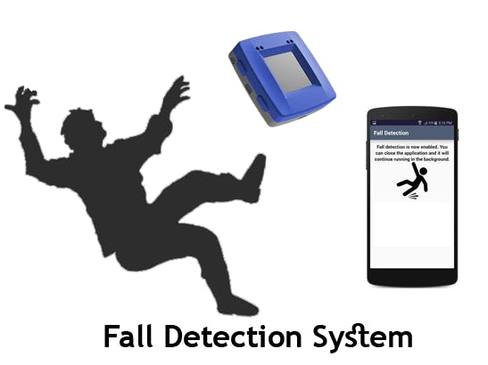With the ever-aging population, there is an urgent need for the development of fall detection systems as falling is among the most damaging event elderly people can experience. The rapid development of sensor networks and the Internet of Things (IoT) can be regarded as an effective method to reduce the problem of fall detection. In order to reduce these types of risks our idea is to design an affordable IoT system that can monitor the motion and the health of elderly people which can detect their fall and alert by an auto-generated call. The system will be designed by using Accelerometer Sensor and Gyro Sensor which will measure the rate of change of angle in respective sensors during various simulated falls.

# LIST OF MATERIALS

* MPU6050 Accelerometer & Gyroscope Breakout
* Red LED
* ATmega328 with Arduino (Uno)
* 10K Resistor

# WORKING

Our idea is to design the product by using Accelerometer Sensor and Gyro Sensor that will help to detect fall and will extract data, develop, and test their algorithms.

The use of both accelerometer & gyroscope is to measure acceleration along a certain axis (for tri-axis, it looks at the magnitude vector rather than the axes separately) and orientation change respectively and is more accurate compared to the separate use of accelerometer and gyroscope.

Here is the algorithm that is based upon the concept of free falling. During a fall, a person experiences a momentary freefall or reduction in acceleration followed by a change in orientation.

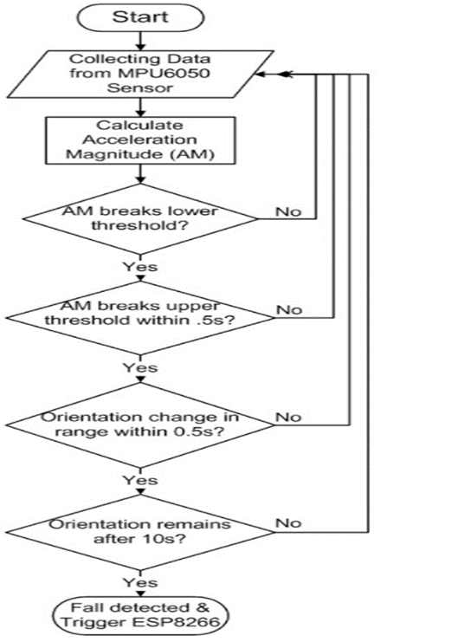 The algorithm checks to see if the acceleration magnitude (AM) breaks a set lower threshold.

If this lower threshold is broken, the algorithm then checks to see if AM breaks a set upper threshold within 0.5s. If this upper threshold is broken, the algorithm then checks to see if the person’s orientation has changed in a set range within 0.5s, which would indicate a person has fallen or tumbled over. If the person’s orientation has changed, the algorithm then examines to see if that orientation remains after 10s, which would indicate the person is immobilized in their fallen position on the ground.

If this holds true, the algorithm recognizes this as a fall. A failure of any of the intermediate decision conditions would reset the triggers and send you back to the start. The strength of this algorithm is that it requires an activity to break two AM thresholds and have an orientation change. The weakness of this algorithm is that it requires the fall to involve an orientation change.

Here we will use MPU6050 which is a 6-axis based motion tracking device. MPU6050 is the combination of 3-axis accelerometer and 3-axis gyroscope with micro electro mechanical (MEM) technology. It is used to detect inclination along axes. Acceleration along axes deflects the movable mass that unbalances the differential capacitor which results 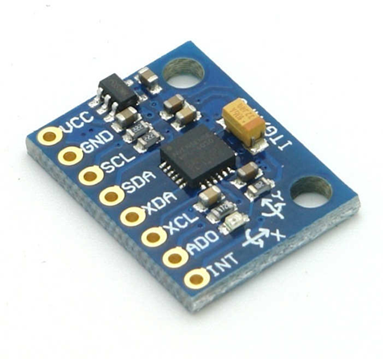in sensor output.

Gyroscope is used to detect rotational velocity along the axes. When the gyros are rotated about any of the axes, the Coriolis effect causes vibration that is detected by MEM inside MPU6050. The resulting signal is amplified and demodulated and filtered to produce voltage that is proportional to the angular rate.

# RESULT

The detection of elderly falls is an example of the potential of autonomous health monitoring systems. While the focus here was on elderly people, the same or similar systems can be applicable to people with mobility problems. With the ongoing development of IoT devices, autonomous health monitoring and assistance systems that depend on on such devices seems to be the key for the detection of early signs of physical and cognitive problems that can range from cardiovascular issues to mental disorders, such as Alzheimer's and dementia. Fall detection has drawn increasing attention from both academia and industry, especially in the last couple of years. The development and deployment of such systems can be able to reduce such incident result in higher accuracy and lower false alarms, while improving the robustness of such systems

# CONCLUSION

Our report provides a description of the components of fall detection system. We draw these following conclusion

* Sensor fusion seems to be the way forward. It provides more healthy solutions in fall detection systems but come with higher computational costs when compared to those that rely on individual sensors.
* Many of the algorithms use accelerometer to detect fall with body orientation, but it is not very useful when the ending position is not horizontal. Fusion of both the gyroscope and accelerometer provides a great enhancement in the fall detection system.

# REFERENCE

* <https://www.frontiersin.org/articles/10.3389/frobt.2020.00071/full>
* <https://innovate.mygov.in/innovation/fall-detection-system/>
* <https://www.instructables.com/Emergency-Fall-Notifier-Cum-Panic-Button/>